**GIT-3**

Construct a branch, do some changes in the branch, and merge it with master (or trunk)

Step1: Creating a New Branch

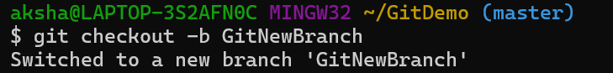

Step2: Listing All Branches

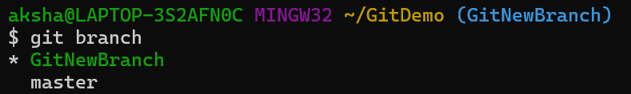

Step3: Creating a New File in the Branch



Step4: Staging and Committing the File

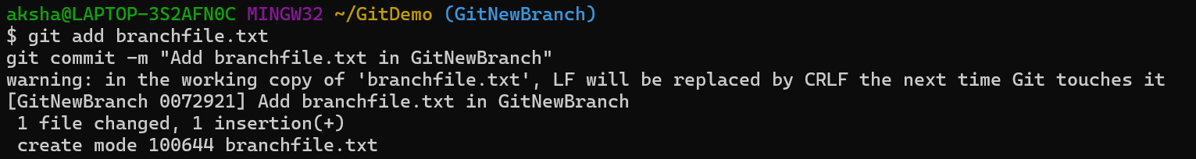

Step5: Checking Status

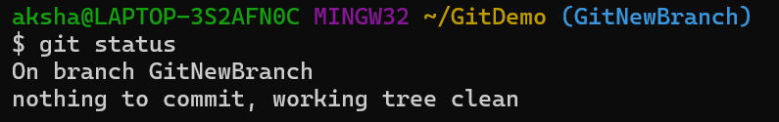

Step6:Switching Back to Master

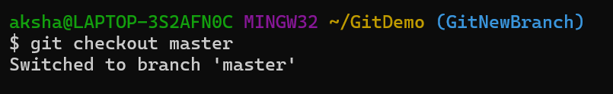

Step7: Viewing Differences Between Master and Branch (CLI)

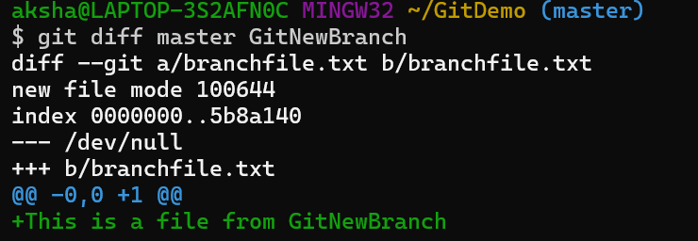

Step8: View Visual Differences Using P4Merge

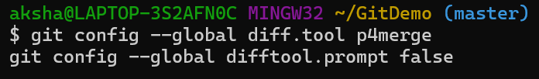

Step9: Merging the Branch into Master

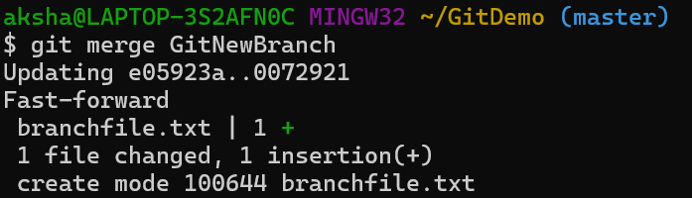

Step10: Viewing the Commit History as a Graph

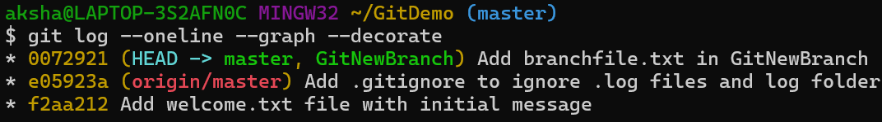

Step11: Deleting the Merged Branch

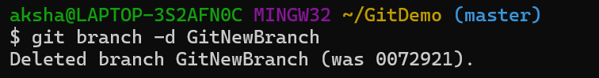

Step12:Checking status

